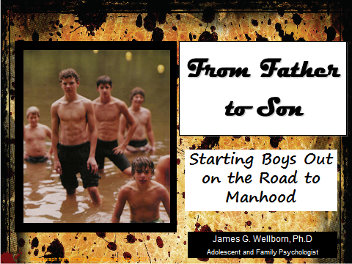

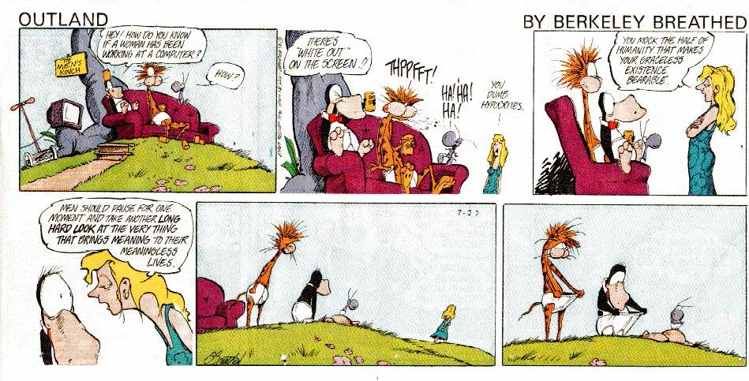

Gender Traits
- Guys
  - Instrumental
  - Competition
  - Dominance
  - Territoriality
  - Toughness
  - Individuality/Independence
- Girls
  - Expressive
  - Group cohesion
  - Cooperation
  - Mutual support
  - Intimacy

Competent, independent and loving men
- Confidence = Independence with cooperation
- Determination = Toughness with sensitivity
- Leadership = Dominance with compromise
- Courage = Invulnerability with openness
- Integrity = Pride AND humility
- Intimacy = Love with vulnerability
- Responsibility = Control with generosity
- Strength = Power with tenderness
- Passion = Intensity with joy

Father to Son Letter

Goal
- Inspiration
- Guidance
- Validation
- Definition of manhood
- Statement of values
- Heirloom

General points
- Developmental considerations
- Length
- Write it and put it aside
- Have someone else read it
- Mix serious and light
- Make it personal
- What about mom

Template

Dear ____

Set the stage
Begin the letter with a statement that marks this moment or event as a time to pause and reflect. Link it to a larger life process or stage.

- You are entering high school, your junior year, graduating
- facing challenges
- preparing for adulthood
- making decisions that will affect your young adulthood

Why this letter
This statement is to let your son know this is more than just a “I love you” letter. They need to know it is talking about the bedrock of personal choices that determine whether they will live a life of integrity and honor (versus one of dissolution and disappointment).
- there are things I want you to know
- this letter is an attempt to talk about some important things
- it is time for you to begin to take on some of the responsibilities of manhood/adulthood
- It is time for you to begin thinking about the kind of man you want to be
- You are going to want to have more freedom and a greater say in your life and with that comes responsibilities and obligations
- We are looking forward to you taking these qualities and building on them over the next couple of years/in college/when you go out into the world.

A man of character
Then, tell your son what you expect of him in terms of character, honor, integrity, morals, principles
- I expect you to be a young man of character. This means
- You will be facing a number of challenges and responsibilities over the next (4) years. By the time you graduate you will need to be ready to be responsible for yourself and begin to contribute to the community
- Faith beliefs

Manhood defined
Here is the heart of the letter; what makes a man, what are the values, virtues or morals you expect them to have.
- Fun, excitement, passion and joy
- There are a number of qualities that distinguish a boy from a man.
- Roles
  - Man
  - Friend
  - Husband/partner/significant other
  - Father
  - Son/family member
  - Student/Employee/Boss
  - Citizen
  - Neighbor
- Areas of life
  - Love
  - School and Work
  - Friendship
  - Marriage/Partnership
  - Sex
  - Alcohol and drugs
  - Community
- Character traits, values, morals, virtues, principles

- Caring
- Charity
- Commitment
- Compassion
- Confident
- Cooperation
- Courage
- Courtesy
- Dedication
- Determined
- Diligence
- Empathy
- Encouragement
- Fairness
- Forgiveness
- Fortitude
- Generosity
- Graciousness
- Gratitude
- Helpfulness
- Honesty
- Honor
- Hope
- Humility
- Humor
- Independence
- Integrity
- Justice
- Kindness
- Leadership
- Loyalty
- Love
- Optimism
- Passionate
- Patience
- Peacemaking
- Persistence
- Politeness
- Prudence
- Religious/Spiritual
- Respect
- Resourcefulness
- Responsible
- Self-discipline
- Self-reliance
- Self-sacrifice
- Sensitive
- Strong
- Temperance
- Tender
- Tolerance
- Tough
- Trustworthiness

Challenges, screw ups, disappointment and failure
Make sure you include a statement about what a man does when he makes a mistake. They will. We all do. They need to know how to recover from it.
- You will make mistakes, it is what you do with mistakes that will set you apart
- When you face challenges, difficulty and failure (in your efforts and your character), I hope you

Your commitment to your son
How are you going to be there for them. What can they expect from you.
- You can count on me
- When you need something
- When I think you need something

End with love and pride
Say it. Clearly and directly. It is important. It grounds them. They need to hear it from you. Set a tone as one of love and pride and confidence in them rather than inadequacy, criticism or fear.
- I love you
- You mother and I love you and are very proud of you.
- You have always been a person who . . .
- There are wonderful qualities you have
- You are a son I am proud of. I want you to be the kind of man you can be proud of.

(This is a well-known poem by Kipling to his son John about the qualities of a man. While most people won’t try to write in rhyming stanzas, it does provide an example of ways to phrase important qualities.)

If
Rudyard Kipling

IF you can keep your head when all about you
Are losing theirs and blaming it on you,
If you can trust yourself when all men doubt you,
But make allowance for their doubting too;
If you can wait and not be tired by waiting,
Or being lied about, don't deal in lies,
Or being hated, don't give way to hating,
And yet don't look too good, nor talk too wise:
If you can dream - and not make dreams your master;
If you can think - and not make thoughts your aim;
If you can meet with Triumph and Disaster
And treat those two impostors just the same;
If you can bear to hear the truth you've spoken
Twisted by knaves to make a trap for fools,
Or watch the things you gave your life to, broken,
And stoop and build 'em up with worn-out tools:
If you can make one heap of all your winnings
And risk it on one turn of pitch-and-toss,
And lose, and start again at your beginnings
And never breathe a word about your loss;
If you can force your heart and nerve and sinew
To serve your turn long after they are gone,
And so hold on when there is nothing in you
Except the Will which says to them: 'Hold on!'
If you can talk with crowds and keep your virtue,
Or walk with Kings - nor lose the common touch,
If neither foes nor loving friends can hurt you,
If all men count with you, but none too much;
If you can fill the unforgiving minute
With sixty seconds' worth of distance run,
Yours is the Earth and everything that's in it,
And - which is more - you'll be a Man, my son!

(This is a beautiful letter that appeared on a popular “mommyblog” written to the blogger’s third grade son. It is a completely different style from the Kipling poem, more emotionally based and less formal. This can be very powerful and a good example of how to address important character issues in a letter to your son from a more tender angle.)

Dear Chase,
Hey, baby. Tomorrow is a big day. Third grade – wow.

Chase – When I was in third grade, there was a little boy in my class named Adam.
Adam looked a little different and he wore funny clothes and sometimes he even smelled a little bit. Adam didn’t smile. He hung his head low and he never looked at anyone at all. Adam never did his homework. I don’t think his parents reminded him like yours do. The other kids teased Adam a lot. Whenever they did, his head hung lower and lower and lower. I never teased him, but I never told the other kids to stop, either.

And I never talked to Adam, not once. I never invited him to sit next to me at lunch, or to play with me at recess. Instead, he sat and played by himself. He must have been very lonely.
I still think about Adam every day. I wonder if Adam remembers me? Probably not. I bet if I’d asked him to play, just once, he’d still remember me.

I think that God puts people in our lives as gifts to us. The children in your class this year, they are some of God’s gifts to you.

So please treat each one like a gift from God. Every single one.

Baby, if you see a child being left out, or hurt, or teased, a part of your heart will hurt a little. Your daddy and I want you to trust that heart- ache. Your whole life, we want you to notice and trust your heart-ache. That heart ache is called compassion, and it is God’s signal to you to do something. It is God saying, Chase! Wake up! One of my babies is hurting! Do something to help! Whenever you feel compassion – be thrilled! It means God is speaking to you, and that is magic. It means He trusts you and needs you.

Sometimes the magic of compassion will make you step into the middle of a bad situation right away.

Compassion might lead you to tell a teaser to stop it and then ask the teased kid to play. You might invite a left-out kid to sit next to you at lunch. You might choose a kid for your team first who usually gets chosen last. These things will be hard to do, but you can do hard things.
Sometimes you will feel compassion but you won’t step in right away. That’s okay, too. You might choose instead to tell your teacher and then tell us. We are on your team – we are on your whole class’s team. Asking for help for someone who is hurting is not tattling, it is doing the right thing. If someone in your class needs help, please tell me, baby. We will make a plan to help together.

When God speaks to you by making your heart hurt for another, by giving you compassion, just do something. Please do not ignore God whispering to you. I so wish I had not ignored God when He spoke to me about Adam. I remember Him trying, I remember feeling compassion, but I chose fear over compassion. I wish I hadn’t. Adam could have used a friend and I could have, too.

Chase – We do not care if you are the smartest or fastest or coolest or funniest. There will be lots of contests at school, and we don’t care if you win a single one of them. We don’t care if you get straight As. We don’t care if the girls think you’re cute or whether you’re picked first or last for kickball at recess. We don’t care if you are your teacher’s favorite or not. We don’t care if you have the best clothes or most Pokemon cards or coolest gadgets. We just don’t care.

We don’t send you to school to become the best at anything at all. We already love you as much as we possibly could. You do not have to earn our love or pride and you can’t lose it. That’s done. We send you to school to practice being brave and kind. Kind people are brave people. Brave is not a feeling that you should wait for. It is a decision. It is a decision that compassion is more important than fear, than fitting in, than following the crowd.

Trust me, baby, it is. It is more important.

Don’t try to be the best this year, honey. Just be grateful and kind and brave. That’s all you ever need to be.

Take care of those classmates of yours, and your teacher, too. You Belong to Each Other. You are one lucky boy . . . with all of these new gifts to unwrap this year.

I love you so much that my heart might explode.
Enjoy and cherish your gifts. And thank you for being my favorite gift of all time.

Love,
Mama
- See more at: http://momastery.com/blog/2013/08/14/it-gets-better/#sthash.QEb21KmX.dpuf

From Father To Son
A Selected Bibliography
James G. Wellborn, Ph.D.

1st Corinthians 13:11
¹¹ When I was a child, I talked like a child, I thought like a child, I reasoned like a child. When I became a man, I put the ways of childhood behind me. ¹² For now we see only a reflection as in a mirror; then we shall see face to face. Now I know in part; then I shall know fully, even as I am fully known.

If by Rudyard Kipling
This is a model of a concise (32 lines) summary of manly virtues done in iambic pentameter.
If you can keep your head when all about you
Are losing theirs and blaming it on you;
If you can trust yourself when all men doubt you,
But make allowance for their doubting too:
If you can wait and not be tired by waiting,
Or, being lied about, don't deal in lies,
. . . .
Yours is the Earth and everything that's in it,
And---which is more---you'll be a Man, my son!

Last Lecture by Randy Pausch
On September 18, 2007, Carnegie Mellon University Computer Science professor Randy Pausch’s gave what the University called The Last Lecture. What would you say if it was the last lecture you would ever give. At the time, he had recently been diagnosed with terminal cancer. His lecture was entitled Really Achieving Your Childhood Dreams. Ten months later he was dead. His lecture became a phenomenon and a magnificent guide to what really matters in life.

This is Water by David Foster Wallace
The text of a commencement address delivered in 2005 to Kenyon College by David Foster Wallace, a novelist and essayist. In it, Wallace emphasizes that “(t)he really important kind of freedom involves attention and awareness and discipline, and being able truly to care about other people and to sacrifice for them over and over in myriad petty, unsexy ways every day.” (He suffered from lifelong depression and committed suicide in 2008 at age 46.)

Heroes for my Son by Brad Meltzer
When Brad Meltzer’s first son Jonas was born eight years ago, the bestselling writer and new father started compiling a list of heroes whose virtues and talents he wanted to share with his son. Abraham Lincoln, Rosa Parks, Jim Henson, Amelia Earhart, Muhammad Ali…and so many more, each one an ordinary person who was able to achieve the extraordinary. The list grew to include the fifty-two amazing people now gathered together in Heroes for My Son, a book that parents and their children—sons and daughters alike—can now enjoy together as they choose heroes of their own.

Letters to a Young Black Man by Daniel Whyte, III
Written from a strongly Christian perspective, Whyte writes about what is important and what is difficult about becoming a strong African American man. Things I Wish Someone Had Told Me When I Was 12 is directly relevant (though, again, there is a strongly conservative Christian underpinning like waiting to have sex before marriage).

The Ultimate Gift by Jim Stovall
Jason is the spoiled grandson of a very wealthy man. As part of his grandfather’s will, Jason will only inherit a fortune if he completes a series of tasks that just happen to be character building: work, value of a dollar, friendship, education, overcoming problems, family, laughter, dreams, generosity, gratitude, living well and loving.

Three Trees by Angela Elwell Hunt (with illustrations by Tim Jonke)
Wonderful fable of the desires of 3 trees for riches, adventure and fame. They each achieved their life’s wish but in ways they did not anticipate. (Spoiler alert) They became the manger that held baby Jesus, the boat in which Jesus calmed the seas and the cross upon which he was crucified. Beautiful way to hint at how God’s purpose (or, for heathens, the narrow view of what constitutes real accomplishment) can result in a profound contribution in the humblest, honorable life.

A Strong Man by Carol Lynn Pearson and Kathleen Peterson
A strong man gives his feet, his back, his arms, his brain but it is in giving his heart that he truly becomes a man. This is a glorious fable about manhood for modern times.

The Knight in Rusty Armor by Robert Fisher
It's a lighthearted tale of a desperate knight in search of his true self. His journey reflects our own--filled with hope and despair, belief and disillusionment, laughter and tears. Anyone who has ever struggled with the meaning of life and love will discover profound wisdom and truth as this delightful fantasy unfolds. The Knight is an experience that will expand your mind, touch your heart, and nourish your soul. While searching for a way to remove the armor that has become stuck on him, a knight finally discovers the true qualities of knighthood.

Questions for my father: Finding the Man Behind your Dad by Vincent Staniforth
This is a little book of a range of questions (adult) kids often wonder or wish they had asked their fathers. It can help you think about things that are worth saying to your kid.

Don’t Sweat the Small Stuff and It’s All Small Stuff by Richard Carlson
100 suggestions for a code to living (more like guidelines really). A great compilation of the kind of wisdom you would want to pass along to your son; so a great resource to skim and pull ones that are particularly important to you.

The Complete Life’s Little Instruction Book by H. Jackson Brown, Jr.
1560 suggestions, advice and mottos for living to pick and choose from. This can be very useful in looking for specific things to suggest to your son that reflect your priorities and values.

50 Things Every Young Gentleman Should Know by John Bridges and Bryan Curtis
This is a wonderful little book about civil, polite behavior. Despite being based on outdated values from a patriarchal and patrician (read that male-dominated and elitist) era, there are lots of implicit messages from these behavioral expectations about how to be a well-mannered, principled person (for men AND women).

Real Boys Workbook by William S. Pollack and Kathleen Cushman
This is the companion piece to Pollack’s wonderful book Real Boys, one of the definitive books on understanding boys. This workbook covers the gamut of issues including understanding about and how to help your son with guy rules and what being a man means. But, it also covers everything else. Excellent resource.

Boys Passage, Men’s Journey by Brian Molitor
Molitor contends that boys and young men must be guided into manhood by design rather than default---without guidance, a boy's transition from childhood to manhood is dangerous and confusing. In this celebratory and hopeful book, he shares how he implemented the principles of lifelong mentoring, intentional blessing, and rites of passage in the lives of his own sons and how you can do the same for yours. He offers creative suggestions on how you can use these principles to design and implement a positive plan for your son's development so he'll become the man God created him to be.

52 Things Sons Need From Their Dad by Jay Payleitner
Lots (about 52) ways you can provide your son with lessons and examples and instructions to live with honesty and self-respect.

From Father To Son: Wisdom for the Next Generation by Allen Appel
The author interviewed sons of all ages on the most memorable and valuable words they received from their fathers. It is a treasure trove of what sons actually find valuable to hear (and that they will actually hear what you have to say).

http://www.artofmanliness.com/
This website is a wonderful compilation of issues, suggestions and considerations of manhood, masculinity and manhood. Lots of good stuff here for writing a letter (e.g., http://www.artofmanliness.com/2012/02/13/how-and-why-to-write-your-own-personalmanifesto/
http://www.artofmanliness.com/2009/05/31/30-days-to-a-better-man-day-1-define-your-core-values/)
and for examining your own struggles as a man.

The Mankind Project
www.mankindproject.org
This is an international organization that provides information, brotherhood, retreats and support for men across the lifespan. Great organization with a lot of diversity of opinions and experiences (but universally inclusive).

http://www.jamesgwellbornphd.com/parents/books/#boy
I also have gathered a number of books on the topic of boys, manhood and masculinity.

Movies and TV series with Positive Fathers
- To Kill a Mockingbird
- Kramer vs. Kramer
- It’s a Wonderful Life
- Dad
- Harry Potter series (Mr. Weasley)
- Boyz n the Hood
- Big Fish
- The Pursuit of Happyness
- The Bicycle Thieves
- Life is Beautiful
- Mr. Mom
- Parenthood
- Ordinary People
- Sleepless in Seattle
- Courageous
- A Boy Called Dad (teenage father)
- All Men are Sons: Exploring the Legacy of Fatherhood (Documentary)
- The Good Men Project (Documentary) http://goodmenproject.com/
- The Other F word (Documentary)
- Fatherhood 101 (Documentary)
- Fathers & Sons (2005 TV movie)
- Andy Griffith (the original black and white series)

Positive Portrayals of Masculine Values
- Movies
  - Lords of Discipline
  - School Ties
  - Four Feathers
  - Saving Private Ryan
  - Swim Fan
  - The Ultimate Gift

- Books
  - My Losing Season
  - Lords of Discipline
  - Breaking Rank
  - Touching Spirit Bear
  - Treasure Island
  - The Chocolate Wars

Resources from Dr. Wellborn

You can find lots of information on all aspects of parenting teens including information about and articles on raising boys.
www.drjameswellborn.com

Look for the regular blog posts on my website under the Articles tab
http://drjameswellborn.com/category/the-blog/
http://drjameswellborn.com/category/theres-a-stranger-in-my-house/

You can sign up for my monthly newsletter to get current information on parenting teens
www.drjameswellborn.com/newsletter

You can find me on social media at
https://twitter.com/JamesGWellborn
https://www.facebook.com/James-G-Wellborn-PhD-205079369560189
https://www.linkedin.com/pub/james-g-wellborn/45/a26/759
https://plus.google.com/113719255192648489948

And, finally, my book on parenting teens is available on Amazon and several ebook formats
http://drjameswellborn.com/raising-teens-in-the-21st-century/
